**Surface Area Quiz***20 points*

**Formulas:**

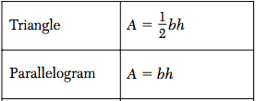 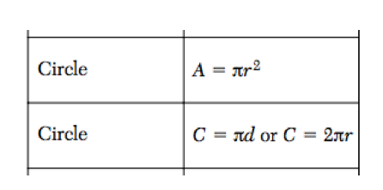

Screen%20Shot%202018-04-15%20at%204.45.16%20PM.pngScreen%20Shot%202018-04-15%20at%204.45.42%20PM.pngScreen%20Shot%202018-04-15%20at%204.40.07%20PM.pngScreen%20Shot%202018-04-15%20at%204.40.14%20PM.png** **

1. 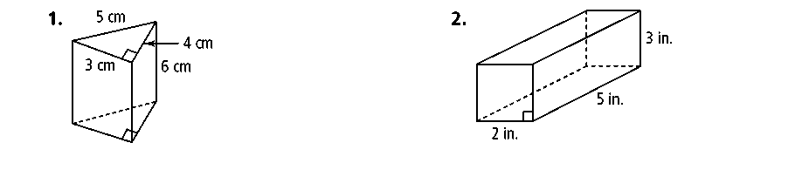  
   1. What type of polyhedron is this?
   2. What 2D shape is formed by a cross section perpendicular to the base?
   3. What 2D shape is formed by a cross section parallel to the base?
   4. What is the Surface Area of this polyhedron?
2. 1. 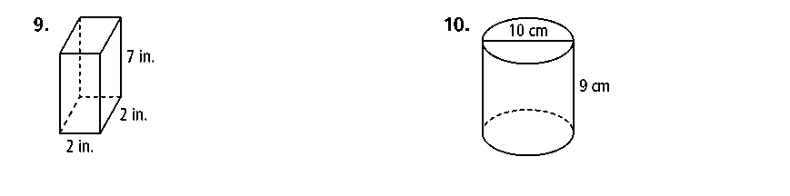What type of polyhedron is this?
   2. What 2D shape is formed by a cross section perpendicular to the base?
   3. What 2D shape is formed by a cross section parallel to the base?
   4. What is the Surface Area of this polyhedron?
3. 1. 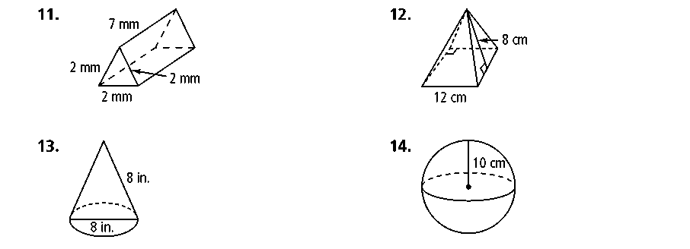What type of polyhedron is this?
   2. What 2D shape is formed by a cross section perpendicular to the base?
   3. What 2D shape is formed by a cross section parallel to the base?
   4. What is the Surface Area of this polyhedron?
4. 1. What type of polyhedron is this?
   2. What 2D shape is formed by a cross section perpendicular to the base?
   3. What 2D shape is formed by a cross section parallel to the base?
   4. What is the Surface Area of this polyhedron?